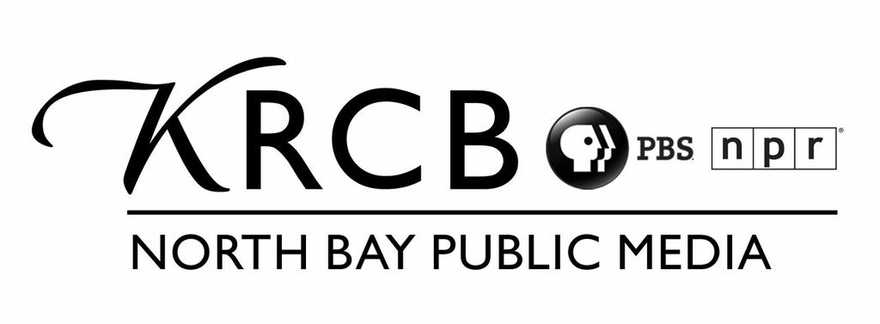FISCAL AGENCY AGREEMENT

PARTIES

Rural California Broadcasting Corporation, a California non-profit 501(c)(3) tax exempt corporation, of 5850 Labath Ave., Rohnert Park, California 94928, hereinafter KRCB, and XXXX XXXX and XXXX PRODUCTIONS, INC., OF XXXX, XX, Producer of XXXX--hereinafter Producer.

PROJECT

By joining this agreement, KRCB and Producer enter into a fiscal agency agreement for a video series/documentary titled “show title” hereinafter-called the “Project.” Producer has provided a detailed description of the Project to KRCB. KRCB has determined that this Project will further its exempt purposes.

AGREEMENT
The parties hereto agree as follows:

ARTICLE I

  - Roles.

Producer shall be wholly responsible for budgeting, writing, casting, videotaping, editing, staffing and otherwise producing the Project. Producer will not be required to devote its full time to the Project, and may engage in other production activities while the Project is in production, but Producer agrees to devote such time and make such efforts as is reasonably required to perform its obligations under this Agreement. KRCB shall provide production and post-production consultation and, if requested by KRCB, shall seek to distribute the Project to Public Television stations on a non-exclusive basis. KRCB will act as fiscal sponsor. KRCB's role as fiscal sponsor will be defined as completed when the Project is completed as specified herein to KRCB and all budget payments to Producer have been dispersed.

1.2 Relationship of the Parties.

Producer and/or subcontractors or staff are independent contractors, and by performing its obligations hereunder shall not be deemed employees or partners of KRCB.

1.3 Right to Hire and Contract Employees.

Producers have the right to choose and/or hire such services as are necessary to satisfy its obligations under this Agreement. If Producer(s) hire employees to work on the Project, Producer(s) must provide proof of workers compensation coverage.

Fiscal Agent Agreement Page 2

ARTICLE II PAYMENT AND BUDGET

  - Submission of Budget and Solicitation of Funds.

Producers have submitted a detailed operating budget (the “Budget”) attached hereto and KRCB has reviewed and approved the Budget. Producers will solicit funds for the Project. Determination of who is solicited shall be the sole responsibility of Producers. Producers shall keep KRCB informed of all solicitation activities connected with the Project to avoid possible conflicts. It is understood that KRCB maintains control over contributions received and if performance criteria are not met, may return funds to a funder.

  - Segregation of Funds.

KRCB agrees to set up a designated Project Accounting Procedure for the purpose of depositing, segregating, and dispersing funds for the Project. Producer shall have full authority, subject to the provisions herein, to expend funds not to exceed the Account Balance, in a manner consistent with the Budget.

  - Administrative Fee.

KRCB shall charge the Project XX % of all donations received as an Administrative Fee. The non-refundable administrative fee will cover such expenses as grant administration, accounting services, and phone costs. The administrative fee shown in the Budget is for budgeting purposes only and shall not be interpreted as the actual administrative fee.

  - Outside Services.

Producer shall present to KRCB check requests and invoices for outside goods and services consistent with the Budget and KRCB shall pay for such services in a timely manner. In certain instances, Producer may request funds in advance for payment of outside services. KRCB shall advance said funds to Producer within five working days of the request.

  - Accounting.

Producer shall prepare and deliver a detailed report of all services and expenditures, together with supporting documents, performed in connection with the Project not less than once a month. In addition, KRCB shall prepare and deliver a detailed account of all Account Activity including current Account Balance not less than once per 90-day period.

Fiscal Agent Agreement –– Page 3

ARTICLE III QUALITY CONTROL

3.1 Warranties.

Producer warrants that the Project is not intended to promote or advertise products or services other than the Project and does not violate any personal or private rights, copyright or trademark, trade name, literary, artist, dramatic or property rights of any individual, firm, or corporation, nor the personal rights or the right of privacy or any other right of any individual, firm or corporation. Producer warrants that all necessary rights, releases, clearances, and/or licenses will be obtained in connection with production of the Project. Producer will ensure the Project observes PBS standards for underwriting, technical and production credit guidelines (located at http://www.pbs.org/producers/). Producer agrees to indemnify and hold KRCB harmless and defend KRCB against any claims of such violations to include costs of defense, if any, of KRCB, its board members, directors, staff or agents. Producer agrees to comply with all laws, state or federal, in the production and or distribution of the Project, including tax laws. If the project budget is greater than $50,000, Producer will submit, in a timely manner, to KRCB proof of submission of appropriate Federal and State taxes and reports.

  - KRCB’S Right of Review.

During the course of the Project KRCB’s representative(s) shall be entitled to review and approve the progress of the Project. KRCB’s approval cannot be unreasonably withheld. If KRCB withdraws its approval, Producer is under no obligation to return funds already expended in connection with the production of the Project. However, KRCB is under obligation to notify funders, with whom KRCB is acting as fiscal sponsor, that KRCB is withdrawing from the Project.

  - Progress Reports.

Both parties agree to provide each other, periodically, and in no event, less than twice annually, a progress report on their respective roles in the Project. The first report will be due six months after the signing of this Agreement and every six months thereafter until the Project is completed as defined herein, unless more frequent reporting is required by a funder or funders. Because of KRCB’s oversight responsibility, if progress reports are not received in a timely fashion, KRCB has the right to terminate this agreement.

ARTICLE IV OWNERSHIP

4.1 Ownership.

Ownership of the Project, copyright therein, and all rights hereto (except those licensed to KRCB herein) will be Producer’s or bound by any contract entered into by Producer relating to the Project. Producer shall keep all materials generated, including notes, scripts, working videotapes and files, rough and final cuts of the Project.

Fiscal Agent Agreement –– Page 4

ARTICLE V INSURANCE

  - Insurance Coverage.

KRCB agrees to name Producer as additional insured with respect to the Project under KRCB's Broadcasters Liability (Errors & Omissions insurance), and General Liability with such coverages as may reasonably be required by the Project’s distributors. Within the limits and conditions of such insurance, Producer agrees to indemnify and save KRCB harmless from any loss, damages or liability arising directly from any negligent act or omission by Producer respecting the Project. KRCB shall not, however, be responsible for any loss, damage or liability arising from acts or omission by Producer, their agents, staff, third parties or others working on the Project over which KRCB has no supervision or control.

ARTICLE VI TERM - TERMINATION

6.1 Term.

This agreement shall become effective as of the date signed by both parties and shall continue in effect for five years unless notice of termination is provided pursuant to the provisions set forth below. The agreement may be extended by mutual consent beyond five years.

  - Termination Upon Default.
Either party may elect to terminate this Agreement upon completion of Project distribution services or in the Event of Default described below, provided that written notice of such an election to terminate is provided to the other party no less than thirty days in advance of said termination. Events of Default shall consist of the following: (a) a party commits a material breach of this Agreement and (1) such breach remains uncorrected for a period of fifteen days after written notice of the breach is provided to the breaching party by the non-breaching party, (b) a party becomes bankrupt or insolvent; or a petition is filed seeking reorganization of a party under the bankruptcy laws or any other applicable debtor’s relief laws or statues of the United States or any state; or a receiver or assignee in bankruptcy is appointed for such parties; or all or substantially all of a party’s assets shall be condemned, seized, attached, or appropriated; (c) a party is voluntarily or involuntarily dissolved or proceedings are commenced therefore; (d) a party sells or transfers all or substantially all of its assets; or foreclosure proceedings are instituted by any creditor of a party with respect to a substantial portion of its assets; (e) Producer(s) fail to provide Progress Reports as described in Section 3.3 or warranties as required in Section 3.1.

Fiscal Agent Agreement –– Page 5

ARTICLE VII ARBITRATION

All disputes arising out of this agreement shall be submitted to final and binding arbitration. The arbitrator shall be selected in accordance with the rules of Arts Arbitration and Mediation Services, a Project of California Lawyers for the Arts.
If such a service is not available, either party may submit such dispute to binding arbitration before a single arbitrator acting under the rules of the Judicial Arbitration and Mediation Services (JAMS) tribunal, sitting in San Francisco, CA. The award issued in either type of arbitration proceeding shall be enforceable in any court of competent jurisdiction. The prevailing party in such arbitration or enforcement proceeding shall be awarded its costs thereof, including reasonable attorneys fees.

Executed on the _____day of ____ , 2018, in Rohnert Park, California.

Signed:

______________________________
For KRCB
Stan Marvin
KRCB NATIONAL PROGRAM DISTRIBUTION

Signed:

___________________________________
XXXX PRODUCTIONS, INC.
Producer: XXXX

